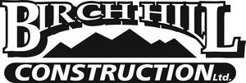

Birch Hill Construction Ltd.

Well established, Moncton, NB based, medium-size excavation company, specializing in municipal sewer & water, site works & subdivision development, currently seeking applicants for experienced Pipe Layers.

As a successful candidate, you will have a minimum of 3 years of relevant experience; have a positive attitude, be an invaluable team player, willing & able to work long hours, some weekend work, have reliable transportation and not possess a criminal record.
Compensation/benefits based on experience and qualifications and will be disclosed in person.
Please email resume and 3 work related references to jobs@birchhillconst.com or fax to 506-858-2736.

