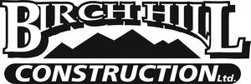

Well established, Moncton, NB based, medium-size excavation company, specializing in municipal sewer & water, site works & subdivision development, is currently seeking motivated, hardworking and reliable flaggers.

To be considered, please submit an up-to-date resume showing valid certification, relevant experience, include 2-3 work related references. Pay based on experience and qualifications and will be disclosed in person.

Please email resume to jobs@birchhillconst.com or fax to 506-858-2736.

